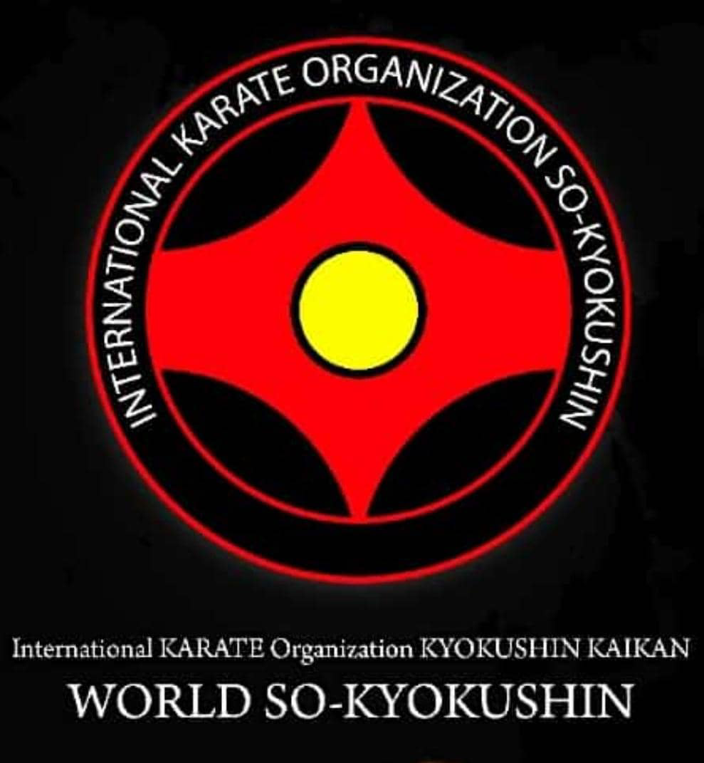

INTERNATIONAL KARATE ORGANIZATION
WORLD SO KYOKUSHIN
MIDDLE EAST CUP
OPEN KYOKUSHINKAI TOURNAMENT
CADETS,JUNIORS and ADULTS
18th – 19 th DECember 2021 ISTANBUL/ TURKEY

Tournament Schedule

17 .12 .2021 00:00 – 17:00 Arrival of Teams
16:30 - 18:30 Reception and accommodation of teams
17:30 - 18:30 Mandate committee and weighing
19:00 – 20:30 Seminar for judges
19:30 - 20:15 Meeting for country representativies
20:30 – Dinner for country representativies
and coaches

18.12.2021 07:30 – 08:30 Breakfast
08:30 – 09:00 The athletes go to the competition area
09.30 – Start of the competition;
09.30 – 13:30 Preliminary matches; A and B Tatamees /
All category
13:30 – 14:00 Lunch break
14:00 - 14:30 Opening seremony
14:30 – 15:00 Award ceremony for Cadets and
Juniors category
15:00 – 16:00 Quarter final matches:
Adults all category
16.00– 18:30 Semi-final/finalfights:
Adults all category
19:00 - 19:30 Award ceremony and closing
of the tournament;

19.12 .2021 07:30 - 09:00 Breakfast
Free time:
for athletes,coaches
and judges
11:00 - 14:30 City Trip
(For Country Representativies
and Honorary guests )

STATUTE
about holding of the Middle East Cup
on World So Kyokushin (cadets,juniors and adults)
1.1. Aims and objectives of Middle East Cup .
2.1. Popularizing and purposefully developing the martial art So Kyokushin in the territory of Turkey and World.
1.2. Enhancing the range of mastership of trainers, judges and sportsmen/women.
1.3. Enhancing the mastership of sportsmen/women at international level.
1.4. Strengthening the cooperation and companionship with the sportsmen/women of other countries.
II. Organized time and venue of the Middle East Cup İnternational So Kyokushin Tournament.
1.1. Middle East Cup İnternational So Kyokushin Tournament.
(Cadets,Junios and Adults) will be held on December 18-19 , 2021
2.2. Arrival date of participants – December 17 , 2021
2.3. Credential Committee: On December 17 , 2021, from 16:00 till 18:00 sportsmen/women must pass from weight classes and medical examination with the participation of delegates.
2.4. Medical examination and weight classes will be conducted in the inn where the sportsmen/women stay.
2.5. Judging December 17, 2021, from 19:00 till 20:30.
III. LEADING OF THE MIDDLE EAST CUP
3.1. Kyokushinkai Fedrasyonu of Türkiye and Representative Turkey of WORLD SO KYOKUSHIN are in charge of the .
3.2. Organizational Committee: is responsible for preparing the venue which will be held the championship according to the norms, keeping the technical-safety rules, legal and moral standards.
3.3. Carrying out the medical sanitary service is entrusted to the medical rehabilitation sector of the Kyokushinkai Federasyonu Türkiye.
3.4 . Invited teams have cover themselves their travel expenses.
3.5. Winners of competition will valuable presents, diplomas and medals by the Kyokushinkai Federasyonu Türkiye and WORLD SO KYOKUSHIN .
IV 1. PARTICIPANTS OF THE MIDDLE EAST CUP
4.1. Weigh classes of the sportsmen and sportswomen who participate in the MIDDLE EAST CUP are as follows:

Weight and Age category
Cadet boys (2009 – 2010 b.d.) / - 30kg – 33kg – 36kg – 40kg ,
Cadet boys (2007 – 2006 b.d.) / - 42kg – 45kg – 50kg ,
Junior boys (2003 – 2005 b.d.) / - 55kg – 60kg – 65kg – 70 kg – 75kg – 75+kg,
Adults male(1995 – 2001 b.d) / - 65kg – 70 kg – 75kg – 85kg – 85+kg,

Cadet girls (2007 -2008 b.d) / - 38kg – 42kg – 45kg ,
Junior girls (2003 – 2005 b.d) / -46kg – 50kg – 55kg
Adults female (1995 – 2001 b.d) / -55kg – 60kg – 60+kg

Rules of KATA Competition:
AGE/GENDER/KYU
Mixed (girls/boys) Individual 11 – 12 years
( 8, 7, 6 kyu )
TOUR 1 :Taikyoku Sono
San,
TOUR 2: Pinan Sono Ichi, TOUR 3 : Pinan Sono Ni

Mixed (girls/boys) Individual 11 – 12 years
( 5, 4, 3, 2 kyu and higher)
TOUR : Pinan Sono San, TOUR 2: Pinan Sono Yon, TOUR 3: Pinan Sono Go

Mixed (girls/boys) Individual 13 – 15
years ( no kyu, 10, 9 kyu )
TOUR 1 :Taikyoku Sono
Ichi
TOUR 2 :Taikyoku Sono Ichi , TOUR 3 :Taikyoku Sono Ni

Mixed (girls/boys) Individual 13 – 15
years ( 8, 7, 6, 5 kyu )
TOUR 1 :Pinan Sono Ichi, TOUR 2 :Pinan Sono Ni, TOUR 3 : Pinan Sono San

Mixed (girls/boys) Individual 13 – 15
years ( 4, 3 ,2, 1 kyu, black belts)
TOUR 1 : Tsuki , TOUR 2 :No Gekisai Sho, TOUR 3 :Competitor choice

Mixed ( female/male) Individual over 16
years ( 8, 7, 6, 5 kyu )
TOUR 1: Pinan Sono Ichi , TOUR 2 : Pinan Sono Ni , TOUR 3 :Pinan Sono San

Female over 16 years - Advanced
(4 kyu – black belts)
TOUR 1 :Gekisai Sho, TOUR 2 :Competitor choice , TOUR 3: Competitor choice

Male over 16 years - Advanced (4 kyu –
black belts)
TOUR 1 :Gekisai Sho
TOUR 2 : Competitor choice, TOUR 3 : Competitor choice

Master (over 43 years)
TOUR 1: Gekisai Sho
TOUR 2 :Competitor choice , TOUR 3 : Competitor choice

Evaluation at KATA will be done with teams of 5 referees (1 x center and 4 x corner)
➢ TOUR I: Notes from 7.00 to 9.00
➢ TOUR II: Notes from 8.00 to 10.00
➢ TOUR III: will be evaluated with flags. The first and second scores will compete for places

1-2; third and fourth scores will compete for 3rd to 4th place.
Competitors may compete in only one category of Kata.
* When calculating the age of contestants, will be taken into account the year and date of birth that contestant is
having at the date of competition.

V. HOLDING CONDITIONS OF THE MIDDLE EAST CUP
5.1. The World Championship is being held according to the rules of the kind of sport So Kyokushin. Competition rules are confirmed by the So Kyokushin .

VI. ORDER
6.1. Orders should be sent no later than 16 Nowember , 2021. They should be up to the shown sample.
6.2. Every sportsperson must have a doctor’s reference and stamp within the orders. There have to be shown information by delegates about each sportsperson. Sportsmen/women who will participate in the Middle East Cup İnternational So Kyokushin Tournament must be the winners of national tournaments and championships. It’s to be sent a photo of sportsperson along with the order (2 pieces of 3x4 photos, possible to send by e-mail).
ATTENTION! Participants have to take a photo wearing dogi. If any of mentioned documents is missing, sports person will not be allowed to participate in the Middle East Cup İnternational So Kyokushin Tournament . Food and accommodation costs fall on teams and representatives.
Entry costs for sportsmen: 50$ - For kumite
Entry costs for sportsmen: 30$ - For kata
İn both categories –60$
This statute is the legal invitation of the Middle East Cup İnternational So Kyokushin Tournament . We attach great importance to this Middle East Cup İnternational So Kyokushin Tournament and we believe that you will bring those sportsmen/women to the Middle East Cup İnternational So Kyokushin Tournament who prepared well and passed from some trial fights.
Sportsmen/women have to be certified to participate in the Middle East Cup İnternational So Kyokushin Tournament.
Contact: Center of Organization Committee. Tel: (mob.) (+90 539) 3080737, (+90 537 4098658)
Address: 1103 sokak 2A, Barbaros Hayrettin Paşa Mahallesi, Gaziosmanpaşa / İSTANBUL

e-mail: info@kyokushinkaifederasyonu.com
sahin.hasanli@gmail.com
canseyspormalzemeleri@hotmail.com

Website: www.kyokushinkaifederasyonu.com

Financing the tournament

All costs associated with orginizing the tournament will be covered by Turkish Kyokushinkai Federation.
Organizers will cover accommodation (hotel with breakfast ) for each team one person / only country representative .
Transfers from airport-hotel, hotel- arena, arena-hotel and hotel-airport will be covered by organizers.Notices: For this / The following conditions apply In the case of designated hotel accommodation (Eser Diamond Hotel,Wish More Istanbul or Marnas Hotels ).

NOTICE:
Entry fee for participation in tournament : Per person for kumite - 50 USD
Per person for kumite 30 USD
İn both categories : 60 USD

Accomadation:
Accomadation Place : Eser Diamond Hotel , Marnas Hotel,
Wish More İstanbul and Esen Palas Hotel

For accomadation details and tecnical details write to sahin.hasanli@gmail.com

THE ORGANIZATION COMMITTEE
Organizer of Tournament:
KYOKUSHINKAI FEDERASYONU TÜRKİYE
Head of organizing committee: Shihan Bülent Memecan
Chieg Judge : Shihan Vahid Bahreman (Head of Middle EAST Region of World So Kyokushin)
Responsible for organizing committee : Sensei Şahin Hasanlı

Contact phones:

(+90) 539 308 07 37 Şahin Hasanlı (Speaks English)
(+90) 539 308 07 37 Şahin Hasanlı (Speaks Russian)
(+98) 916 915 35 00 Shihan Vahid Bahreman (Speak Persian)
(+90) 538 633 55 80 Mahmud Afura (Speak Arabic)

OSU,
Dear Shihan, Sensei, Sempai
I am pleased to invite you and your team to attend the 1st edition of MİDDLE EAST CUP, an international competition addressed to children, cadets, juniors, seniors, that will be in 18 - 19 December 2021 in İSTANBUL, TURKEY.
All necessary details you will find in attached invitation!
Looking forward see you in İSTANBUL!
OSU
Shihan BÜLENT MEMECAN

